Name: Mrs. Rupali N Hosmani.

Course: Executive Post Graduate Certification in Cloud Computing

Contact No. 7720003531

**Assignment 4: Kubernetes**

**Task To Be performed:**

**A] Assignment 1:**

● Deploy a Kubernetes Cluster for 3 nodes

● Create a nginx deployment of 3 replicas

Steps:

1.Create 3 EC2 ubuntu instances with 2cpu’s & 4 GiB ram :

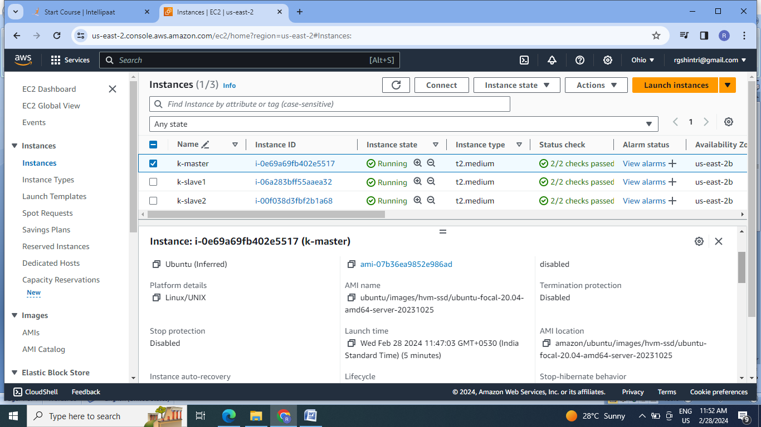

2.Install Docker & kubeadm on all instances:

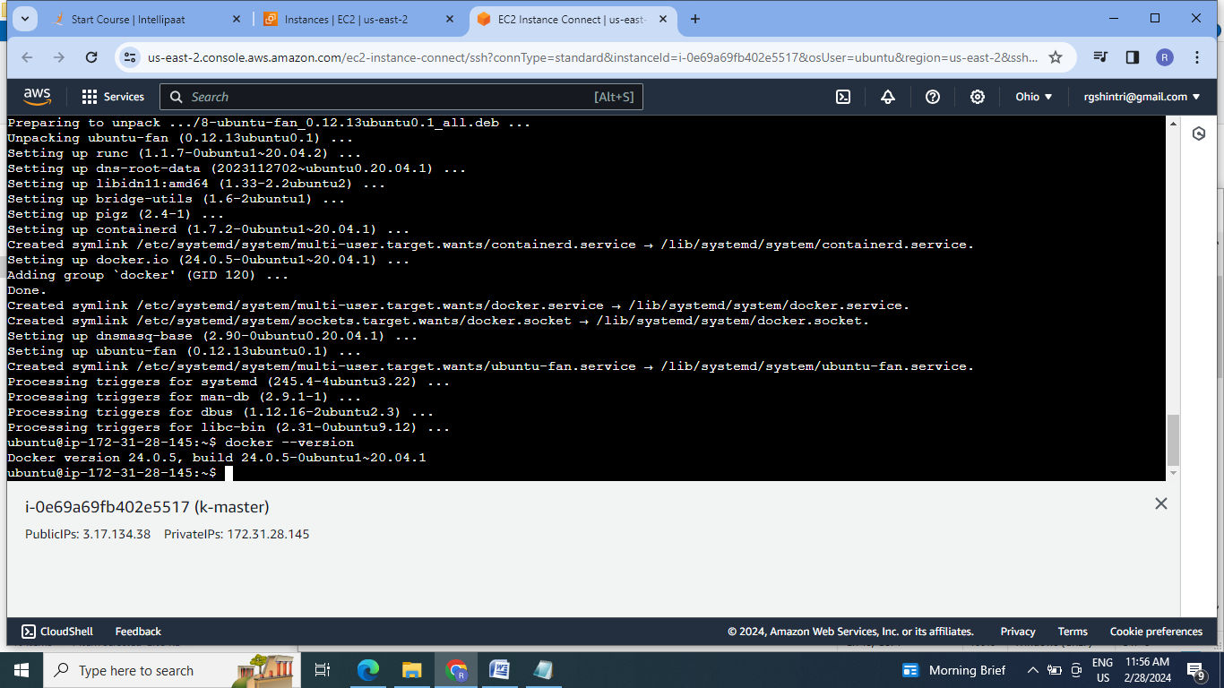

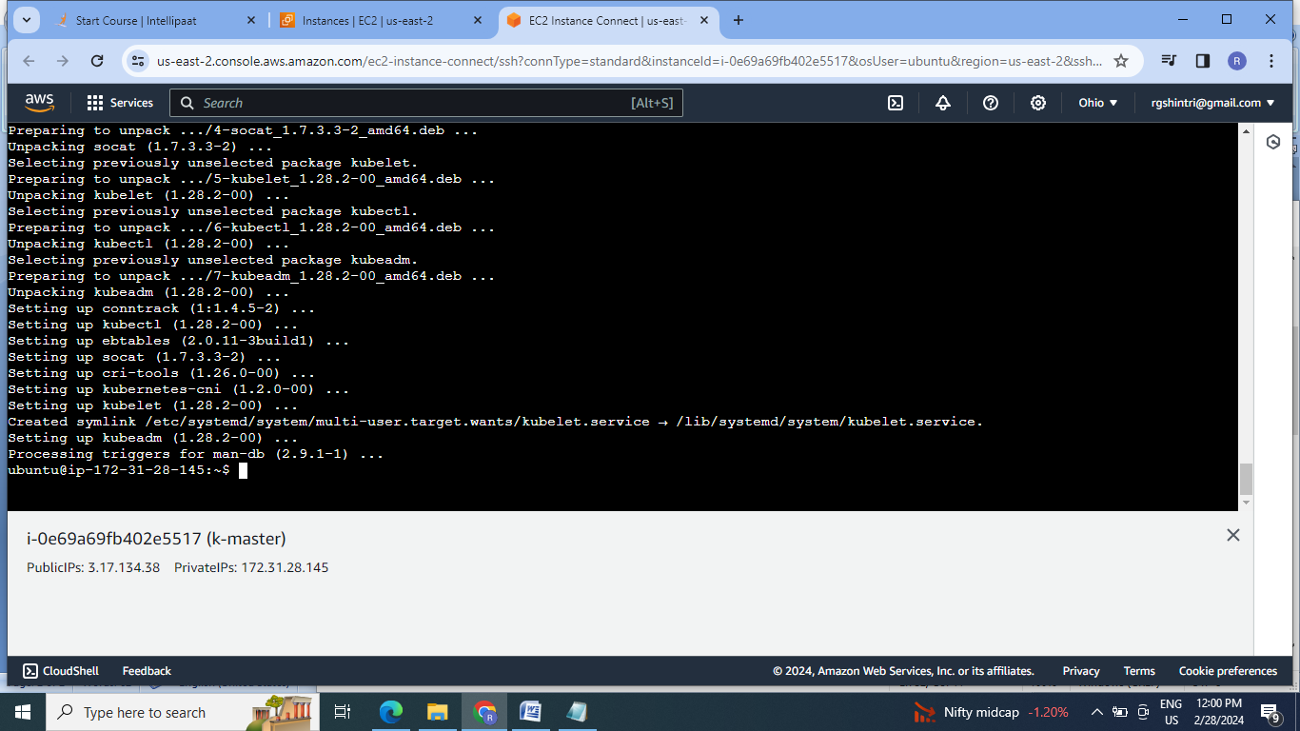

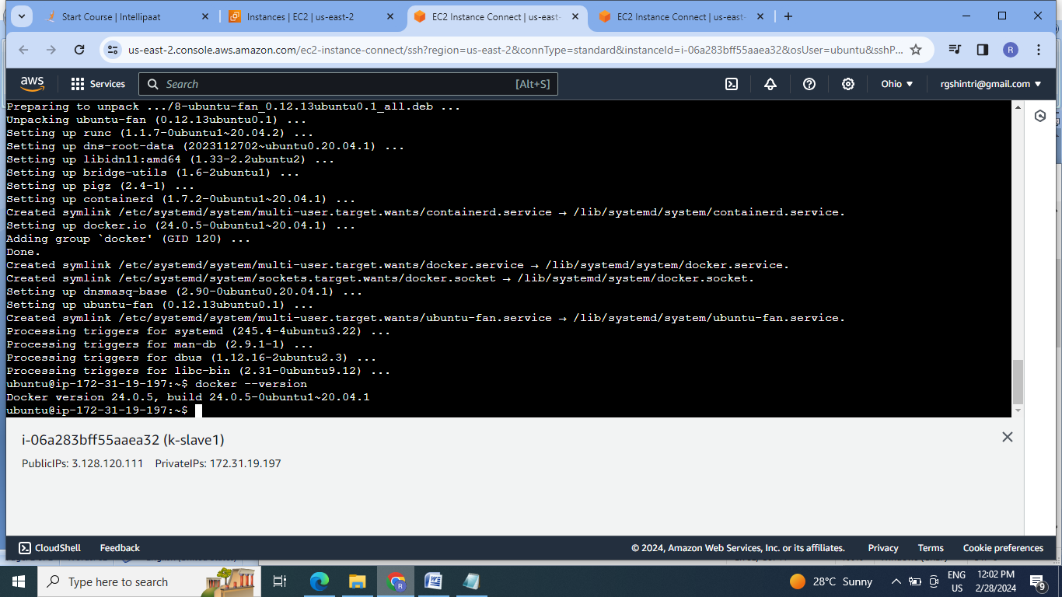

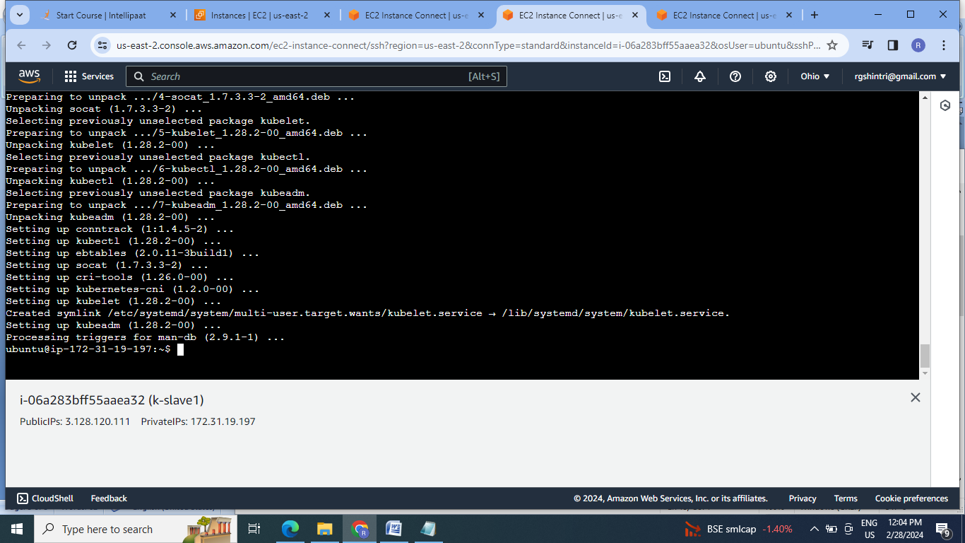

3.Generate the token at master & paste it on both the slaves for making master-slave cluster:

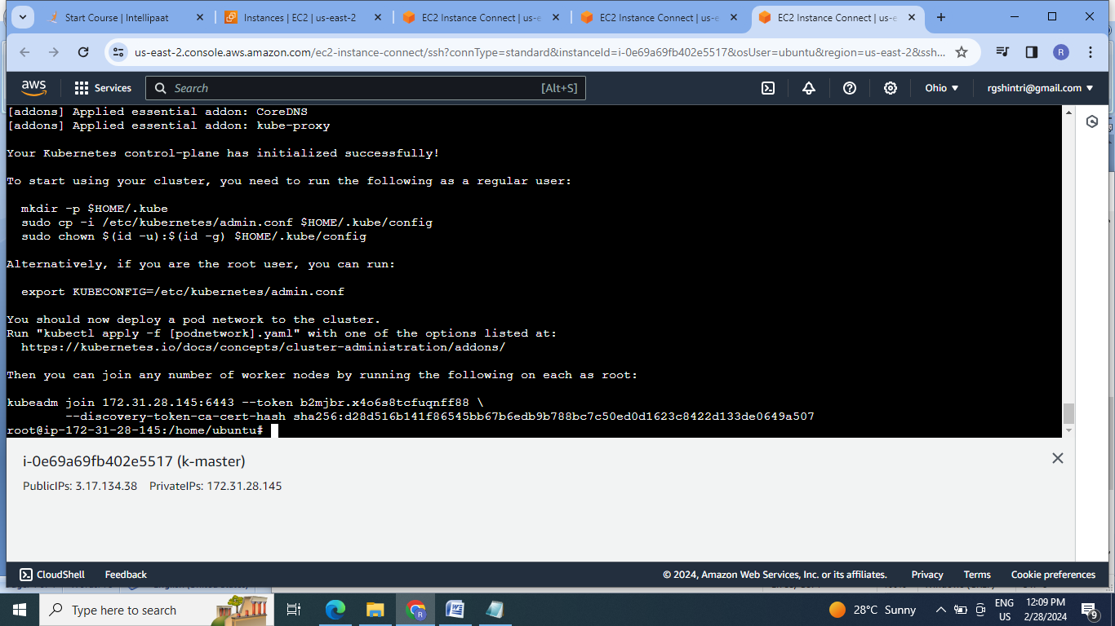

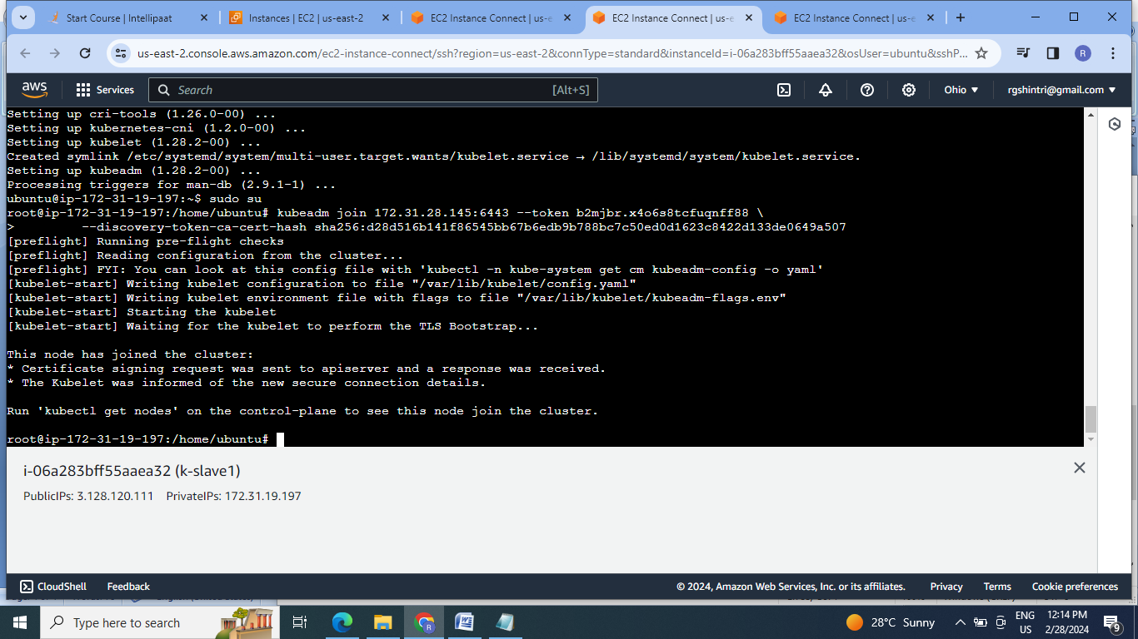

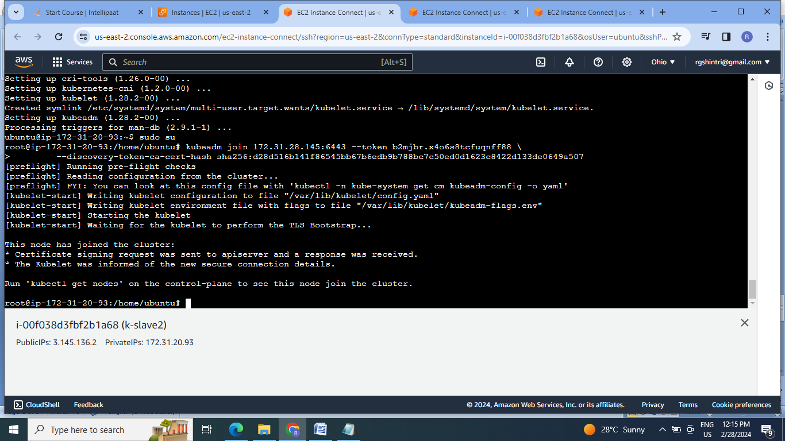

4. Check for cluster formation:

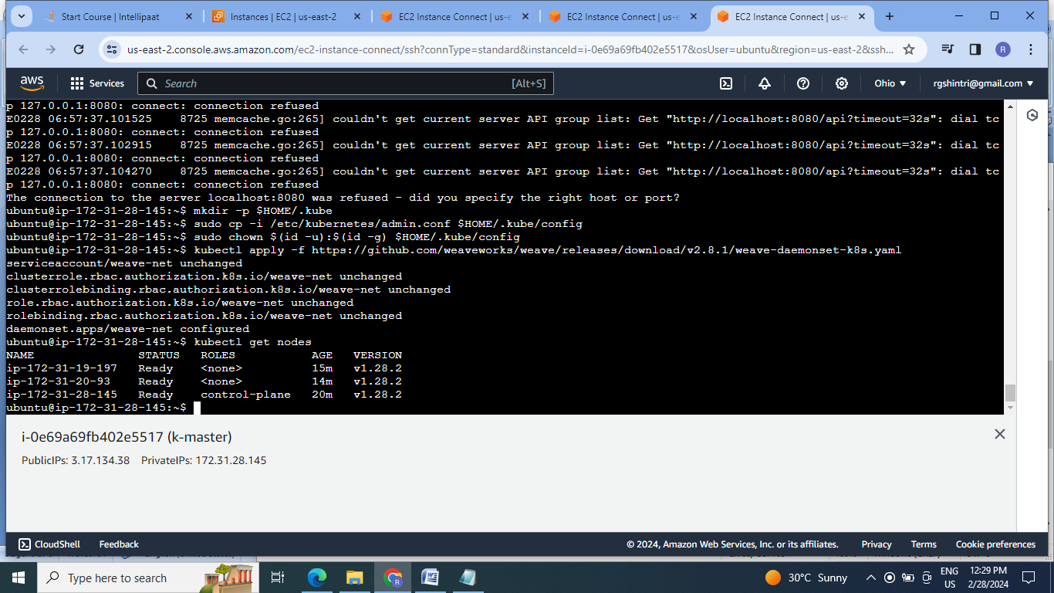

5. Create a nginx deployment of 3 replicas.

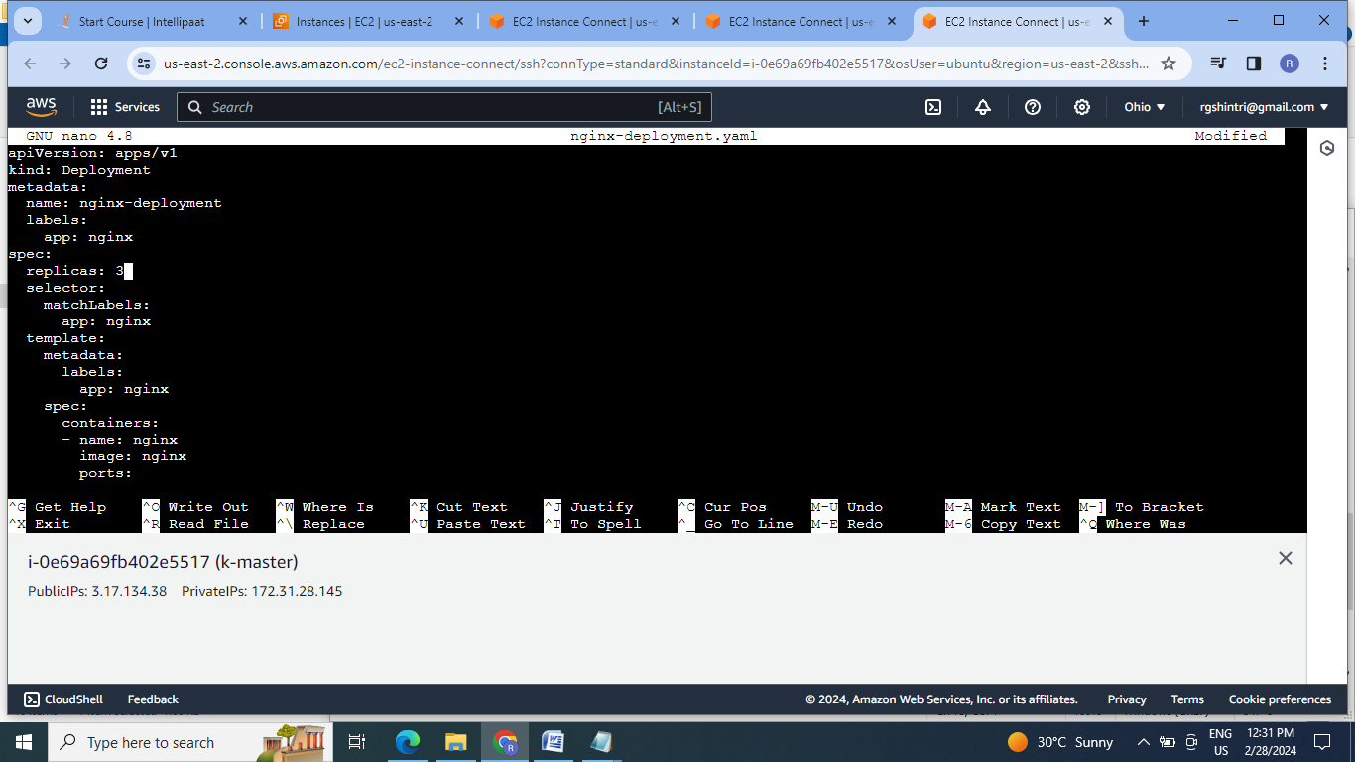

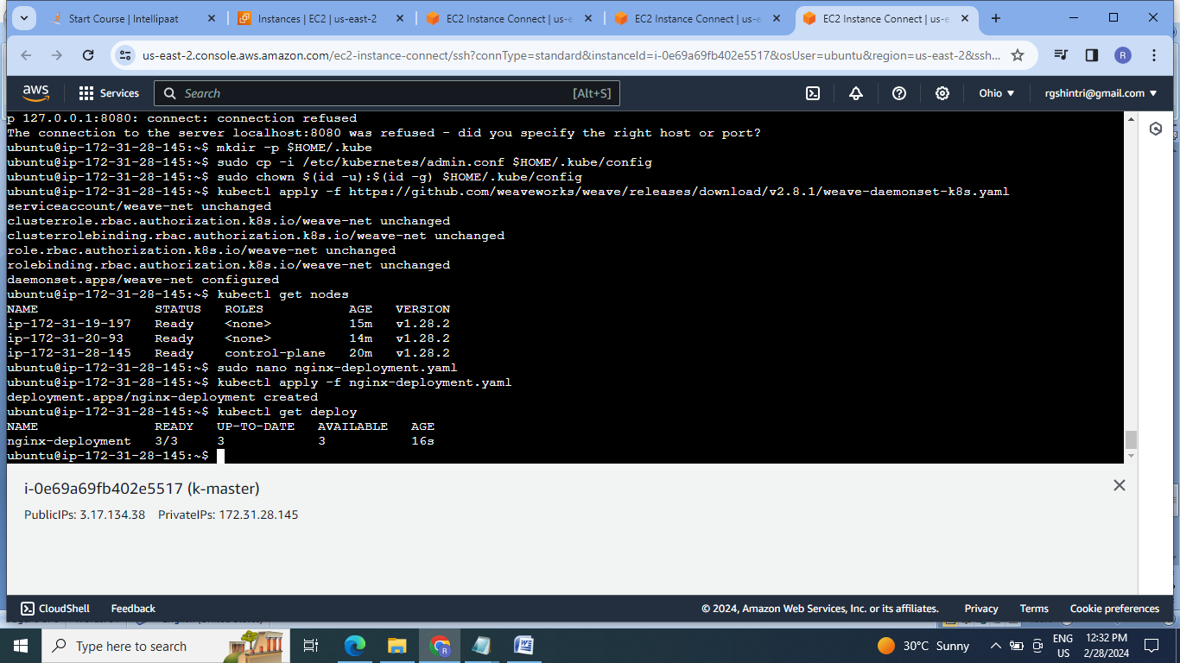

**B]Assignment 2:**

● Use the previous deployment

● Create a service of type NodePort for nginx deployment

● Check the nodeport service on a browser to verify

Steps:

1.Create service file & run it:

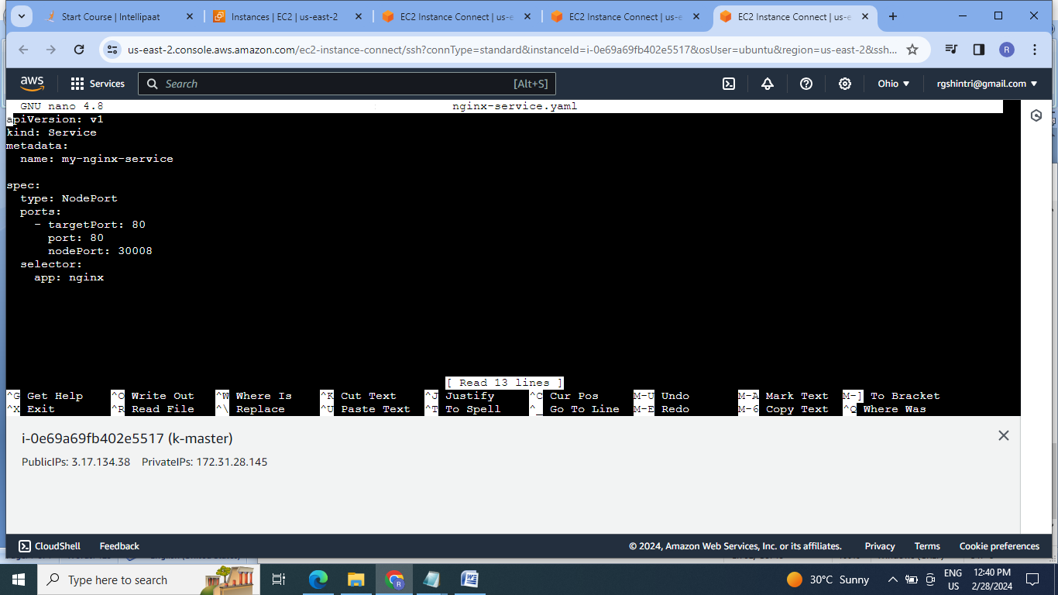

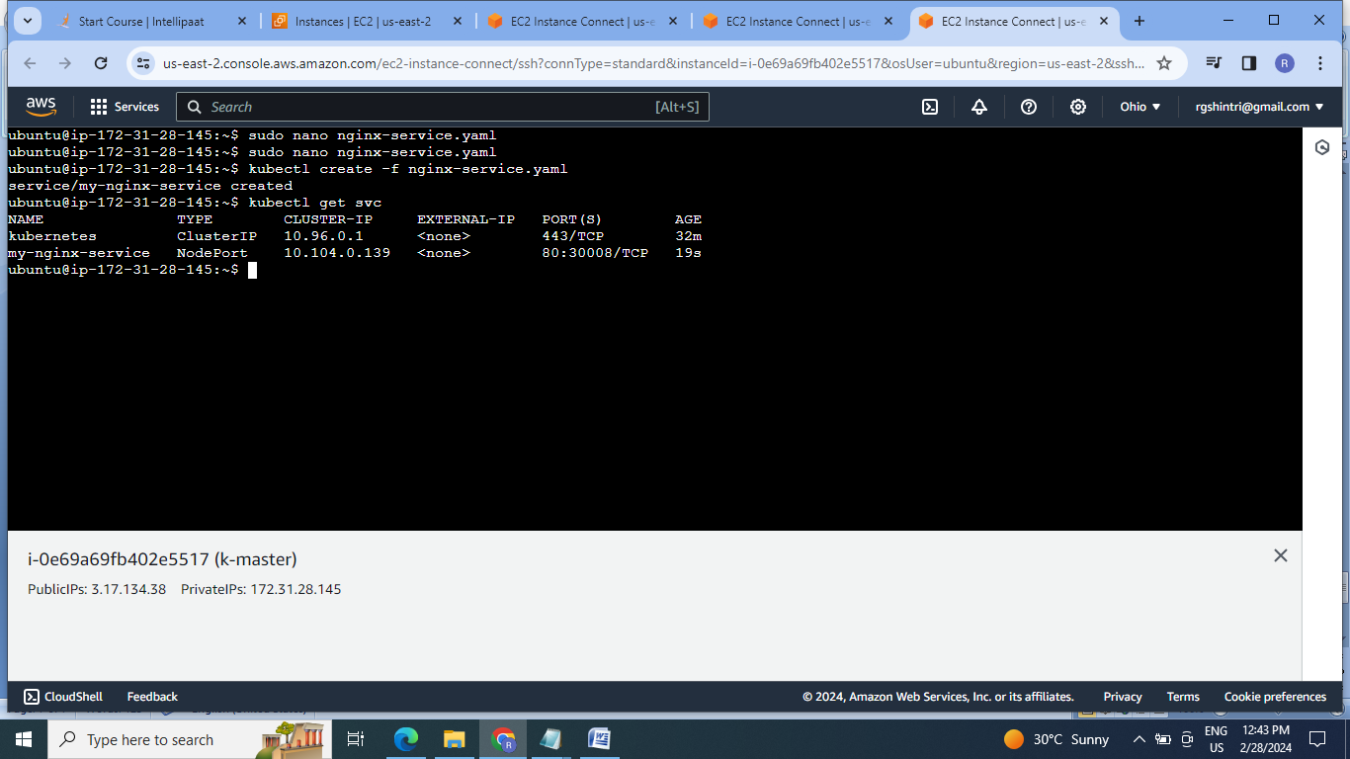

2.Check the nodeport service on a browser to verify:

At master:

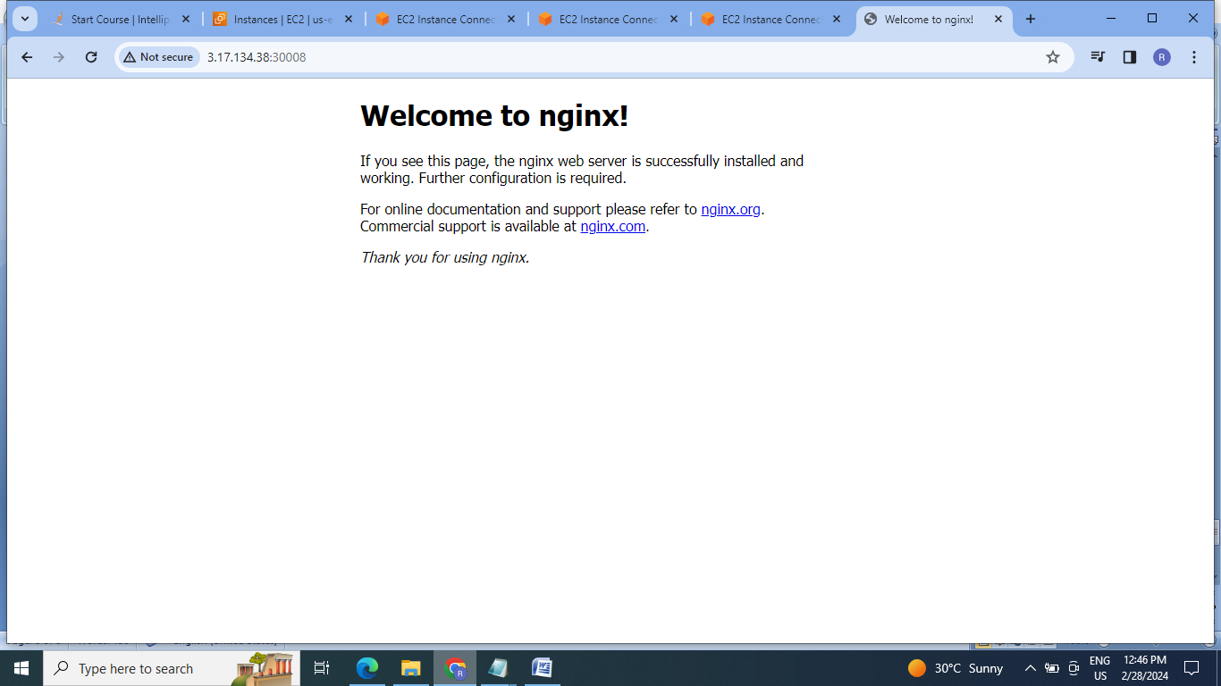

At slave1:

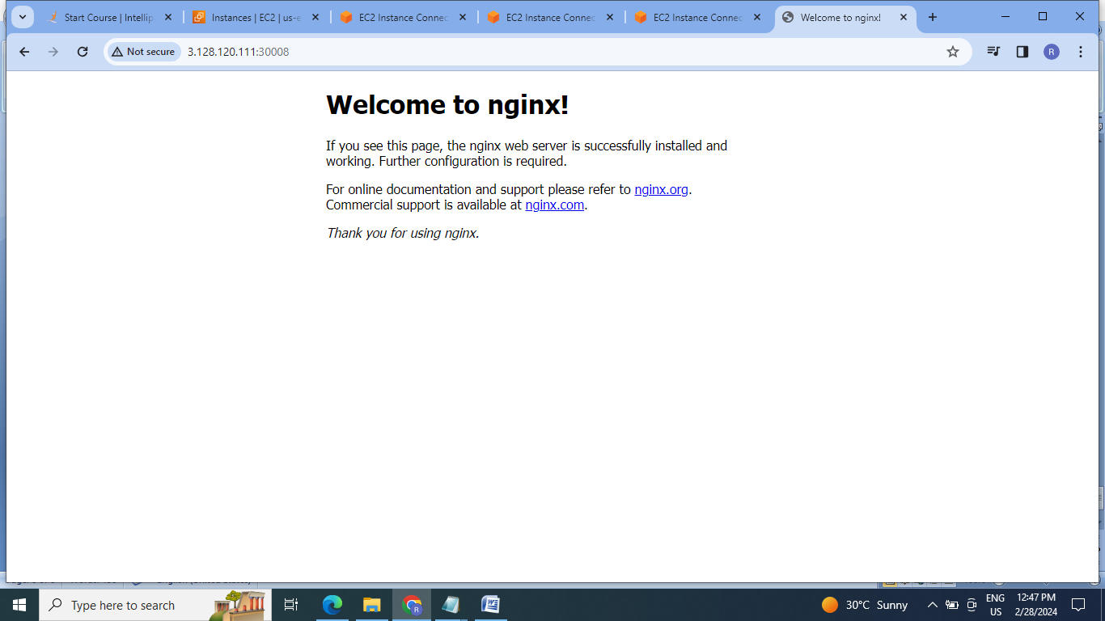

**C]Assignment 3:**

● Use the previous deployment

● Change the replicas to 5 for the deployment

Steps:

1.Current replicas are 3:

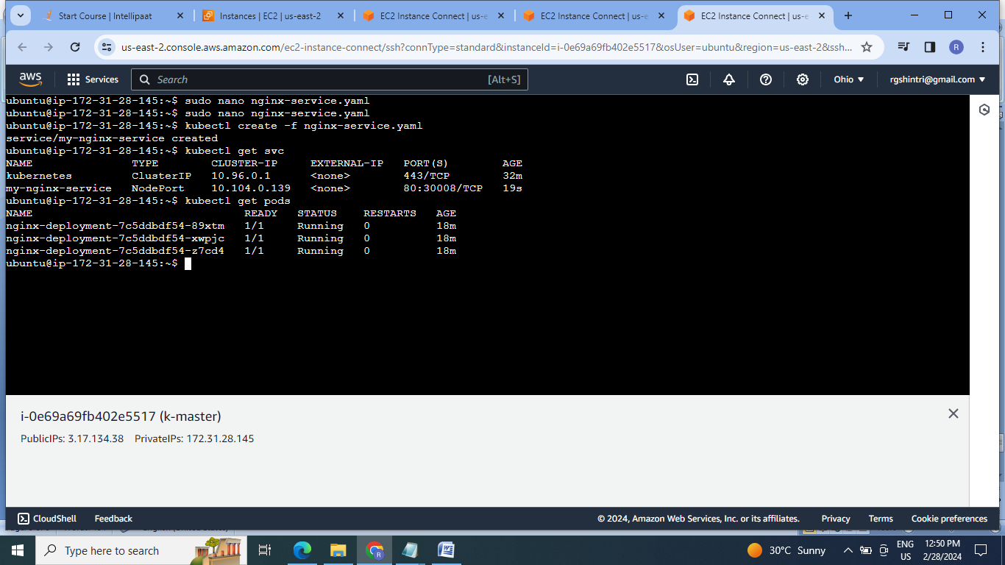

2.Change the nginx-depolyment file for no.of replicas as 5 ,save & run the deployment:

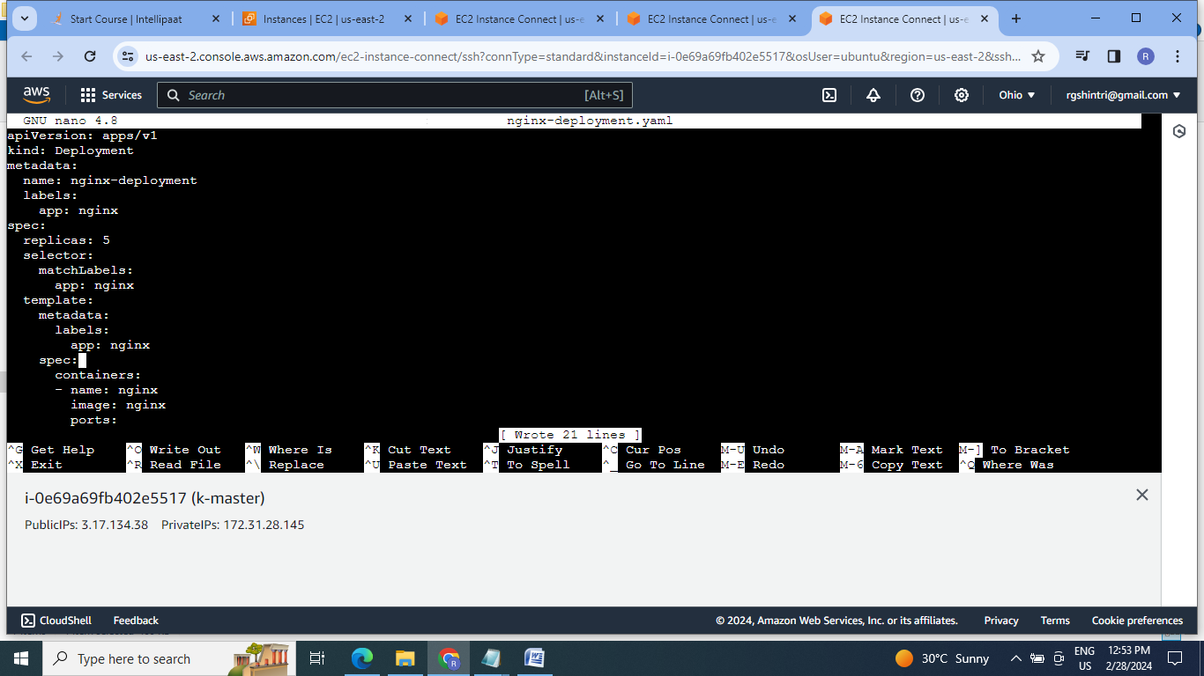

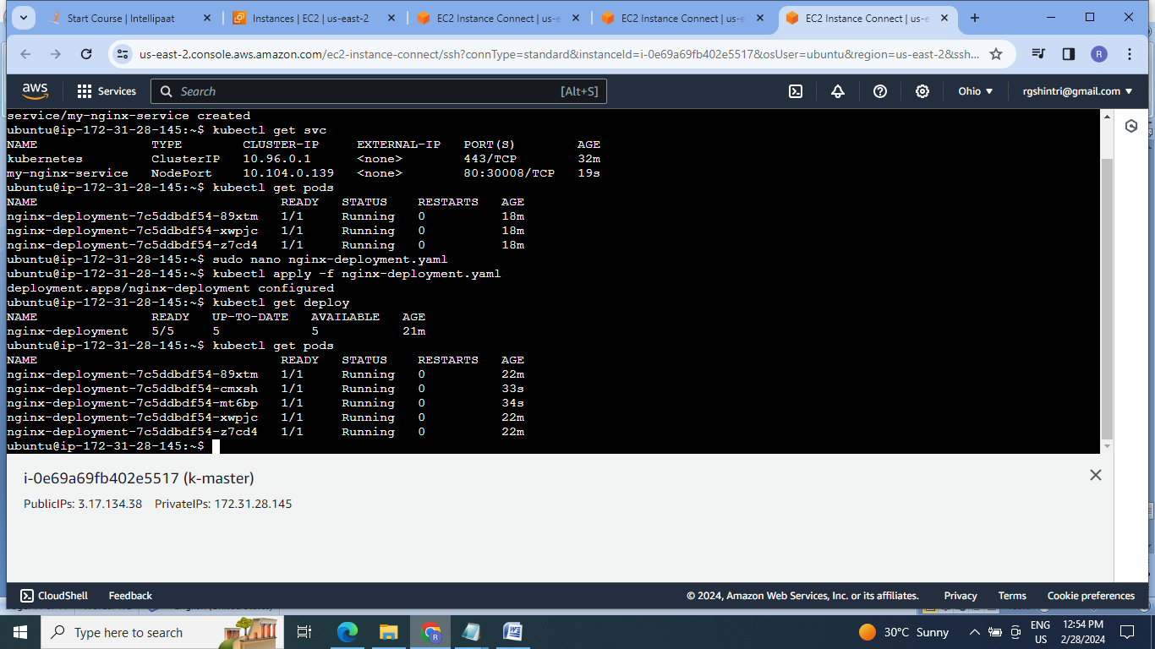

**D] Assignment 4:**

● Use the previous deployment

● Deploy an apache deployment of 3 replicas

● Create an apache service of type clusterip

● Create an ingress service /apache to apache service /nginx to nginx service

Steps:

1.Create EC2 instance & Install MInikube .

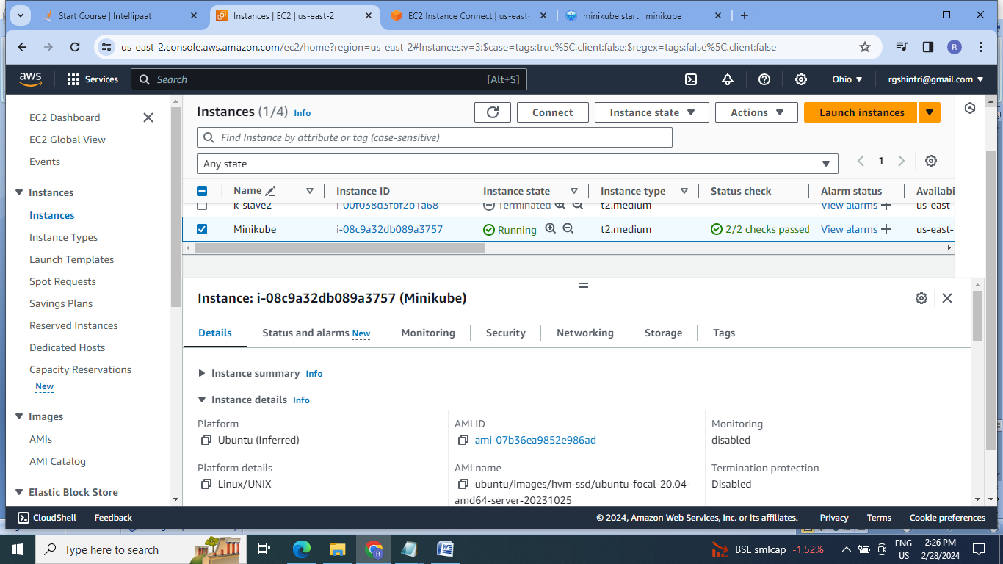

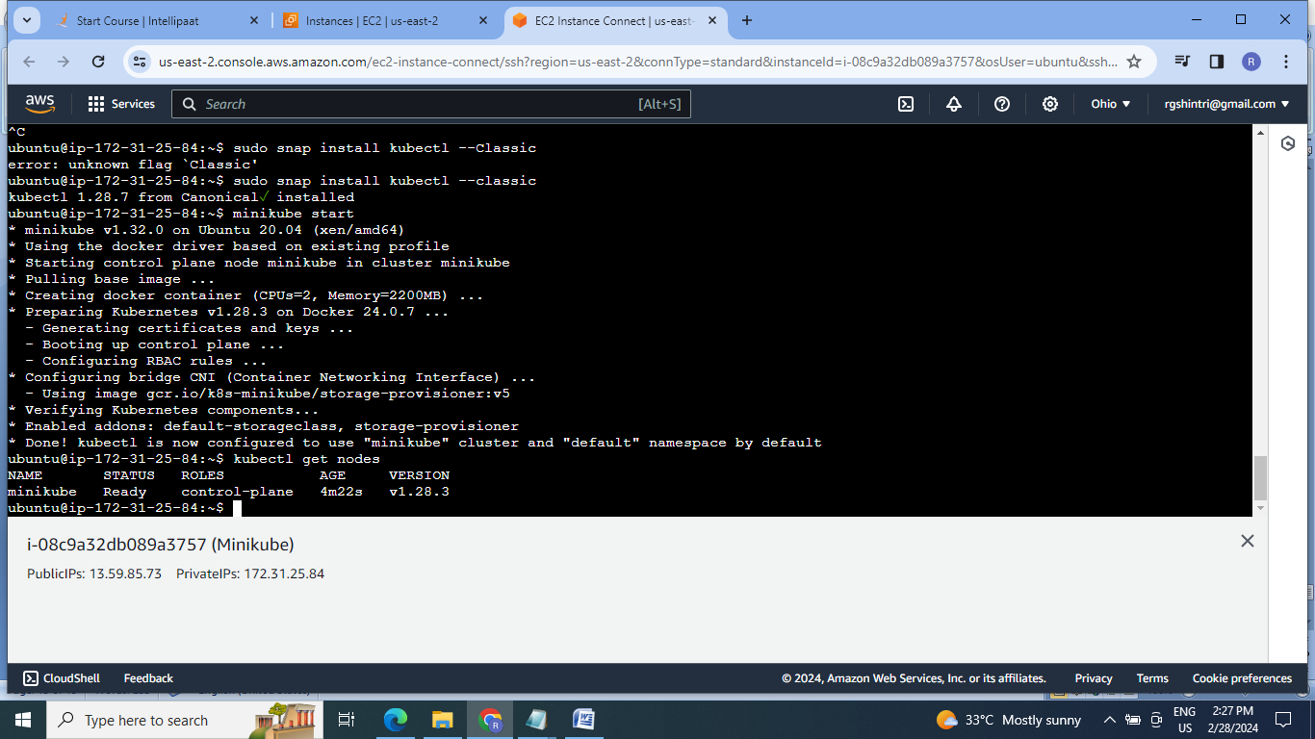

2.Create & deploy nginx deployment & apache deployment of 3 replicas:

Nginx deployment:

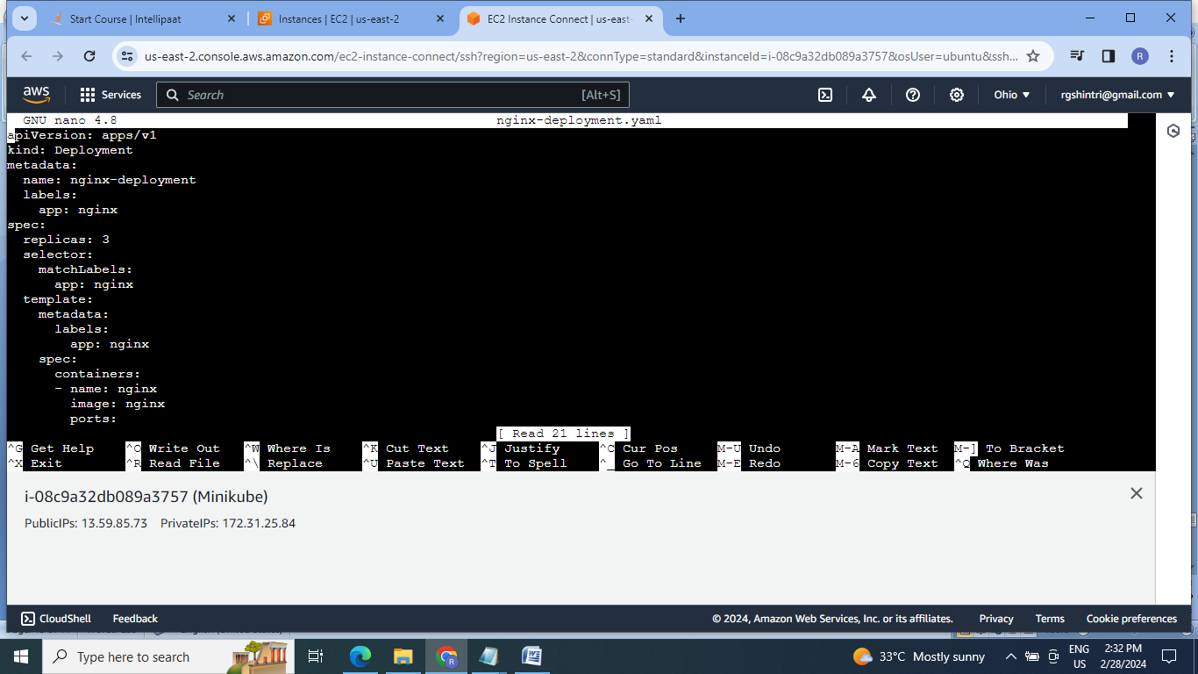

Apache deployment:

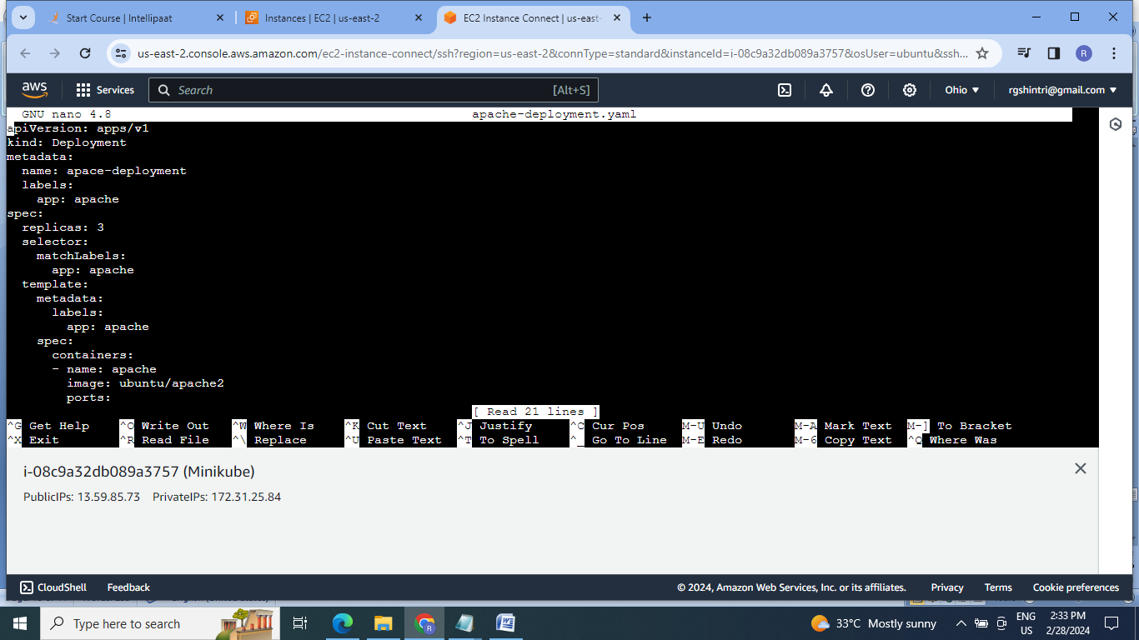

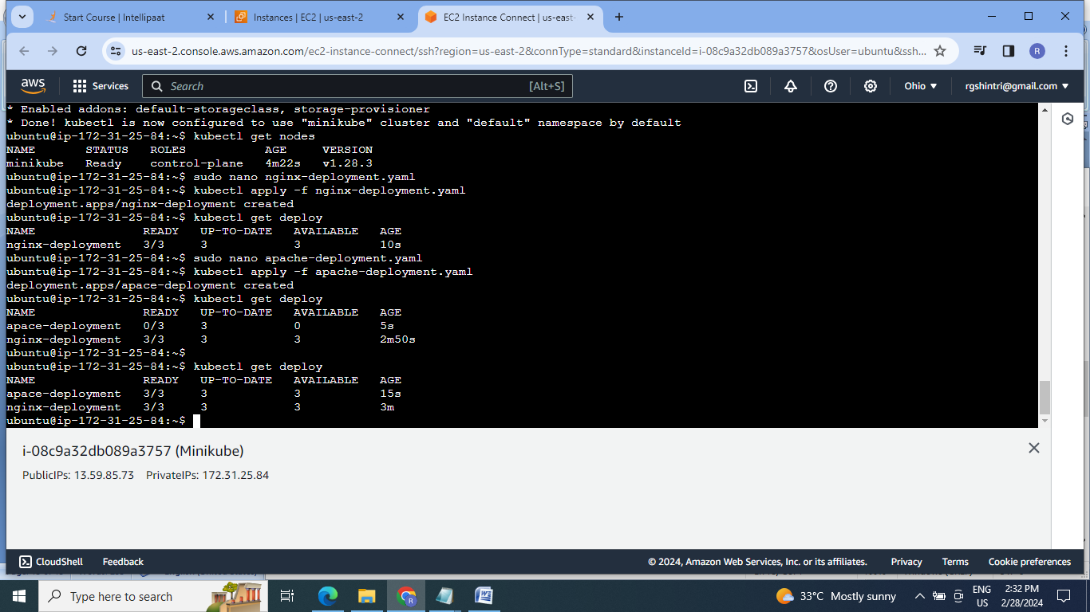

3..Create & deploy nginx service & apache service :

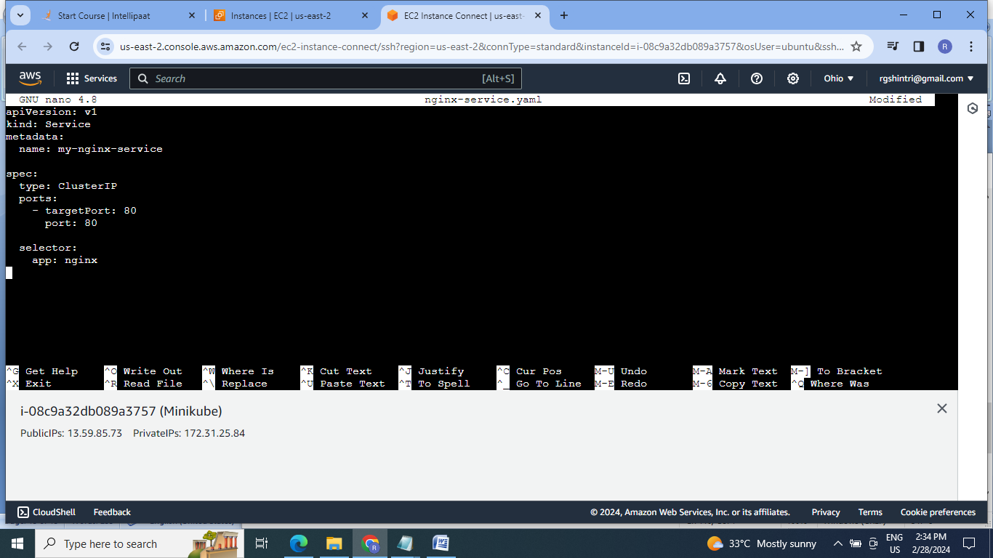

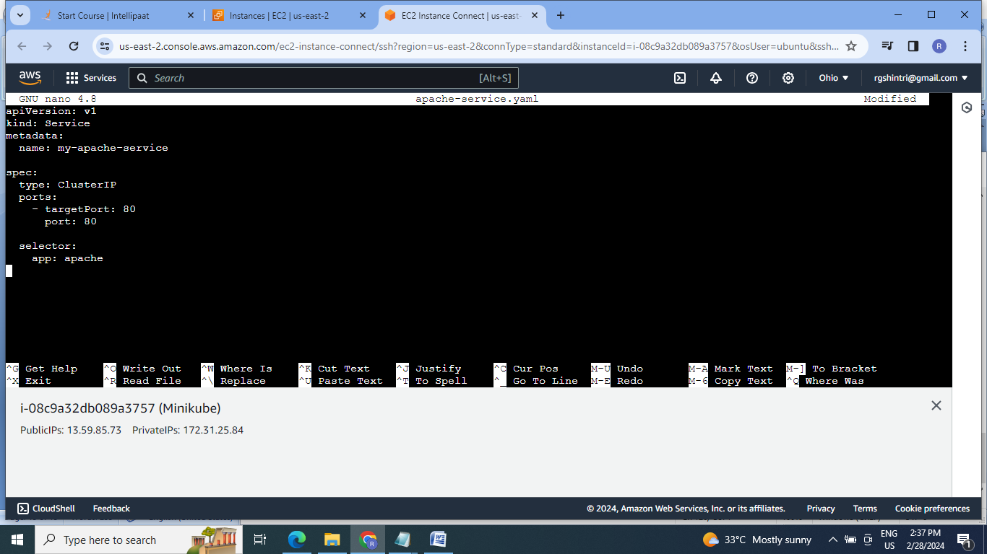

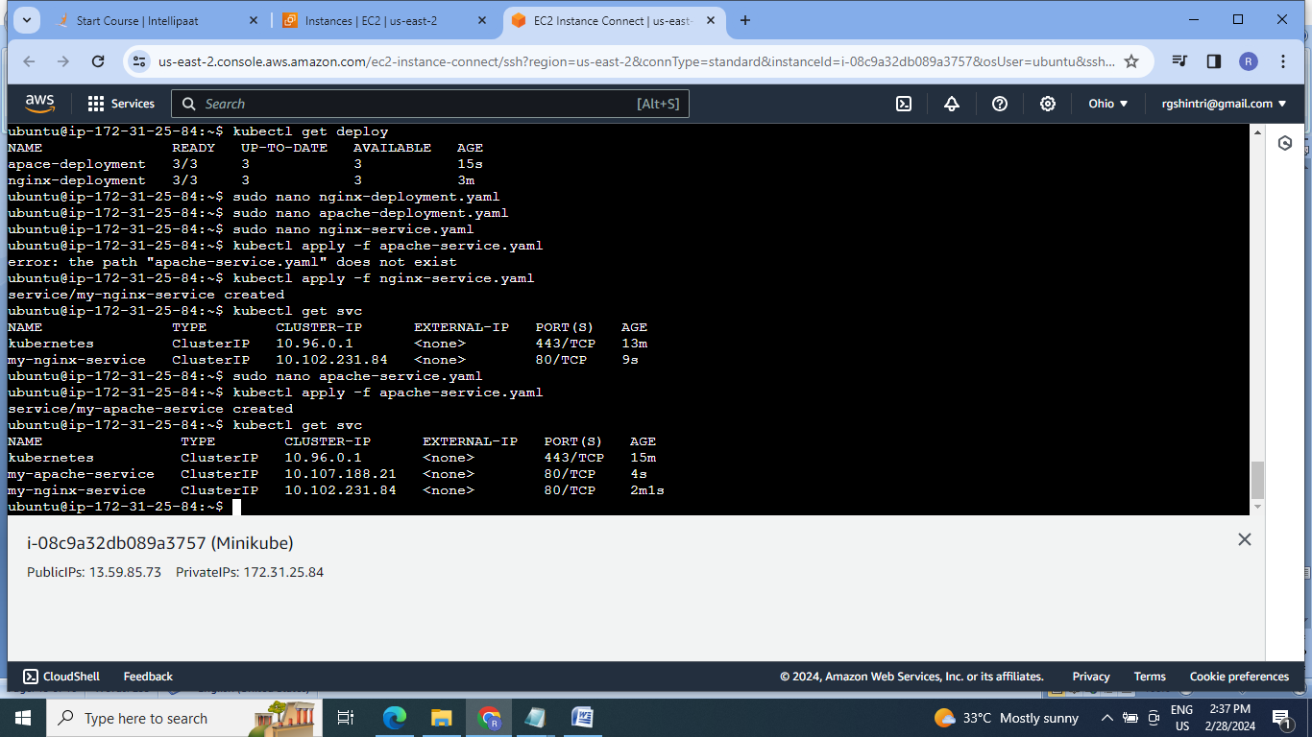

4. Enable ingress service :

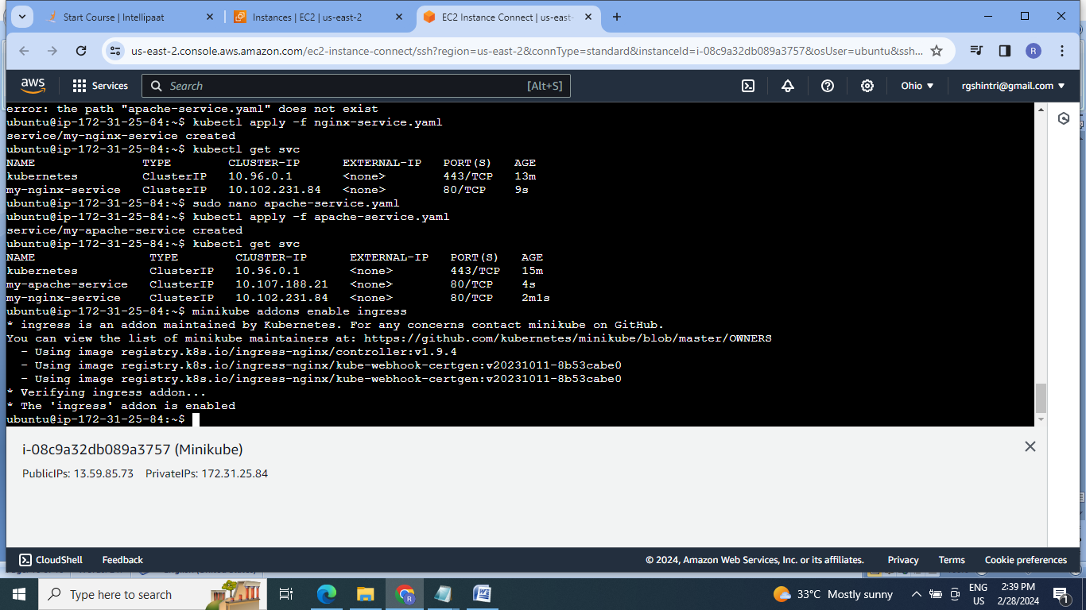

5.Create ingress service /apache to apache service /nginx to nginx service:

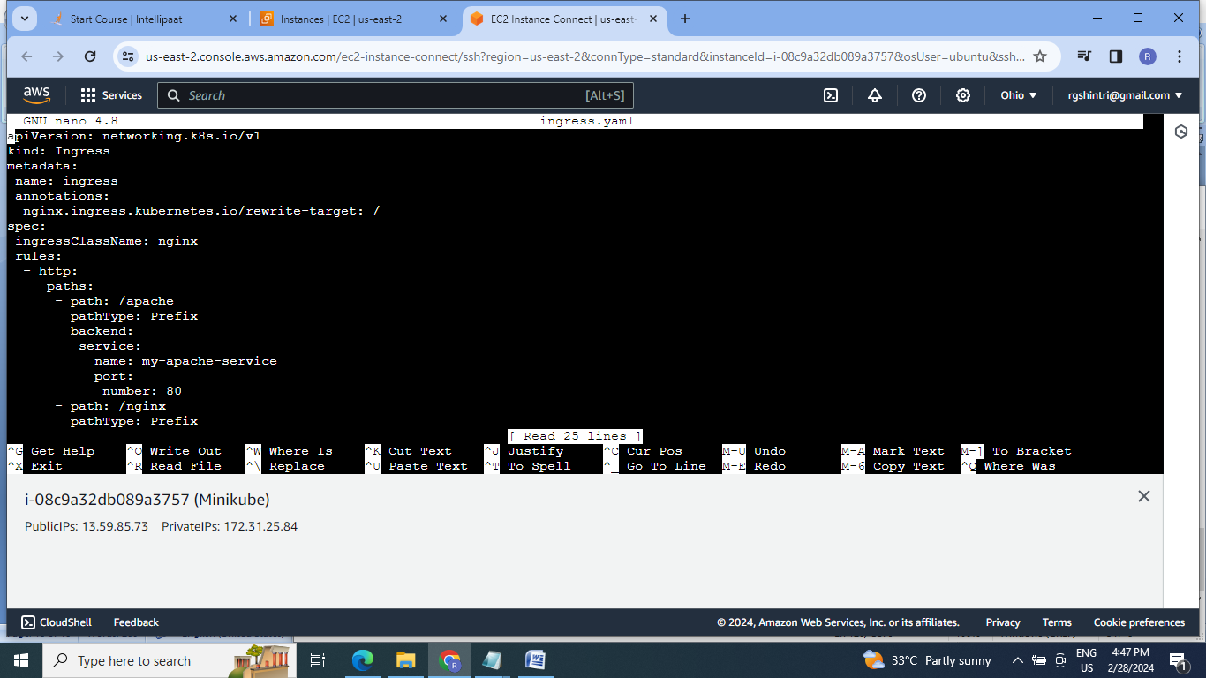

6.Create port forwarding:

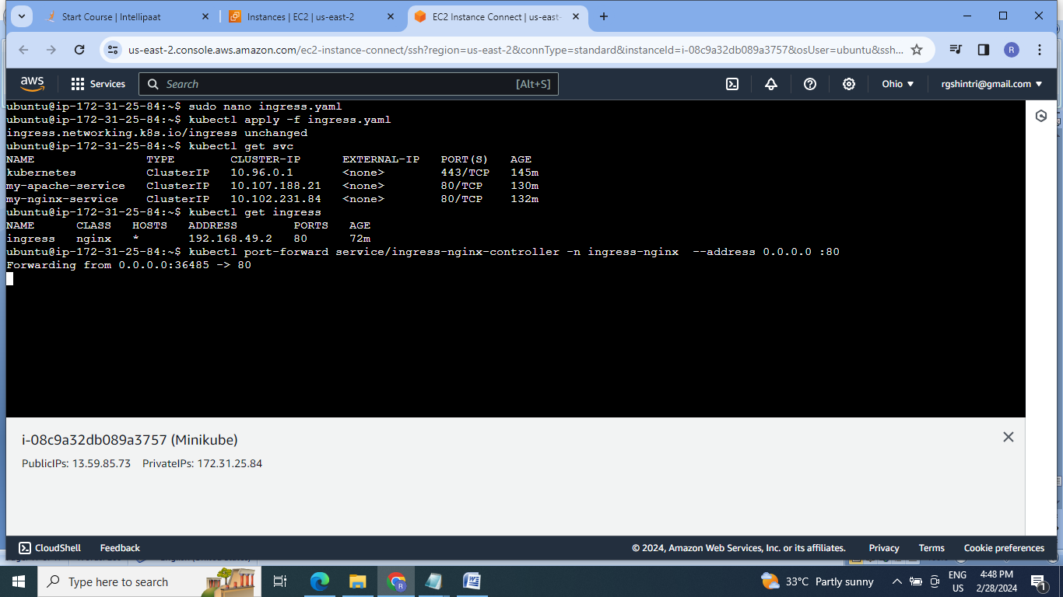

7.Check for both services on browser:

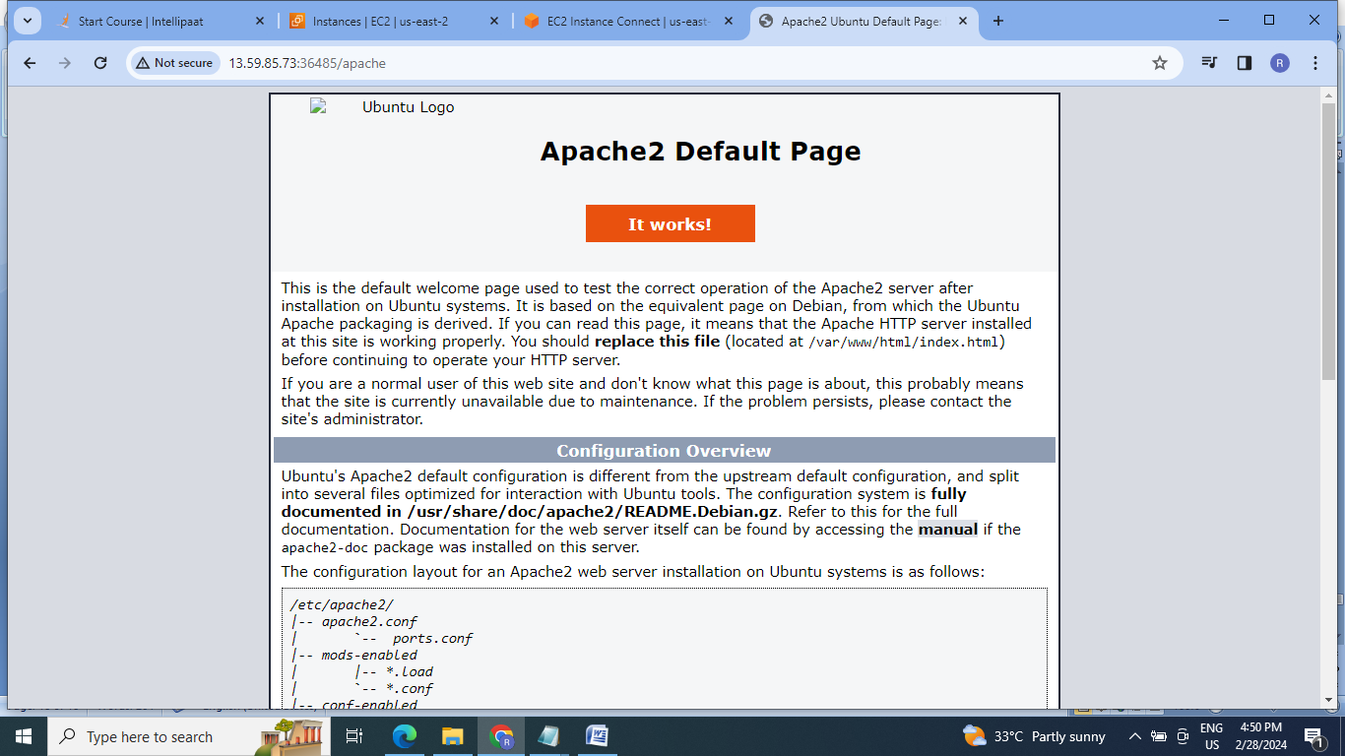

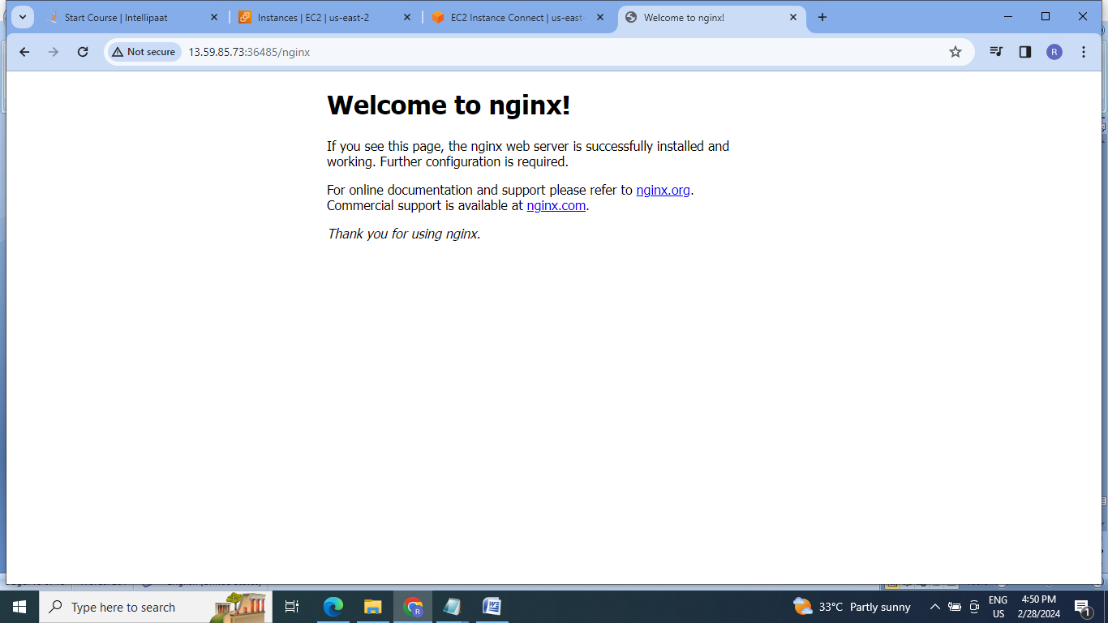

**E]Assignment 5:**

1. Create a persistent volume

2. create a persistent volume claim

3. create a secret “xyzIsthebest”

4. Taint one of the nodes of the cluster

Steps:

1.Create persistent volume yaml file & deploy it

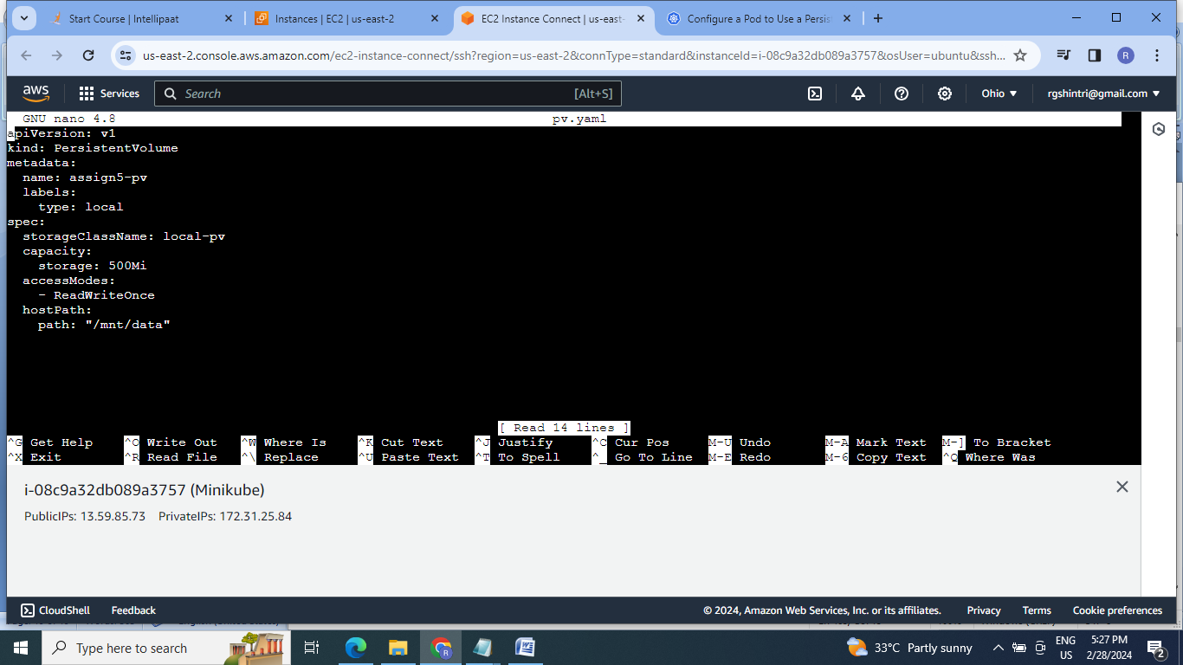

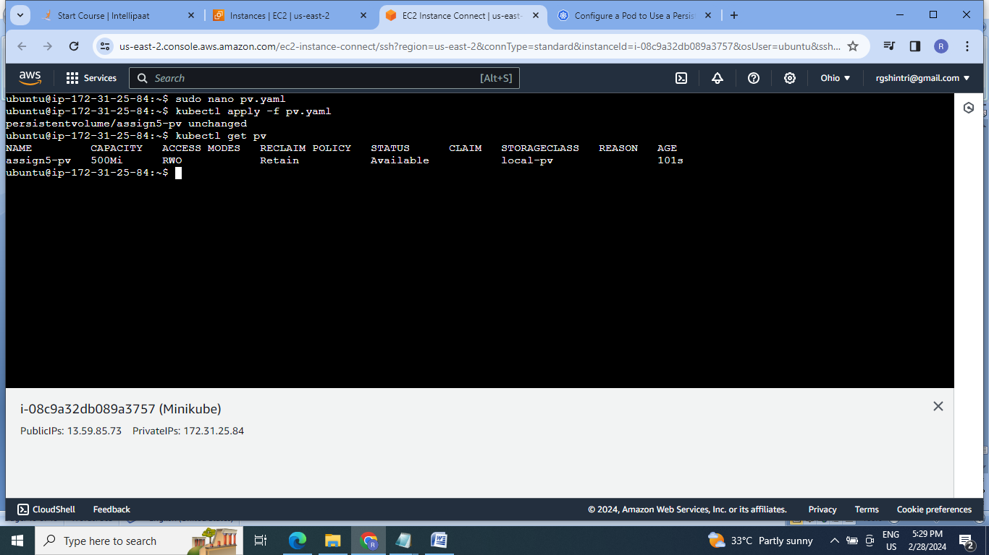

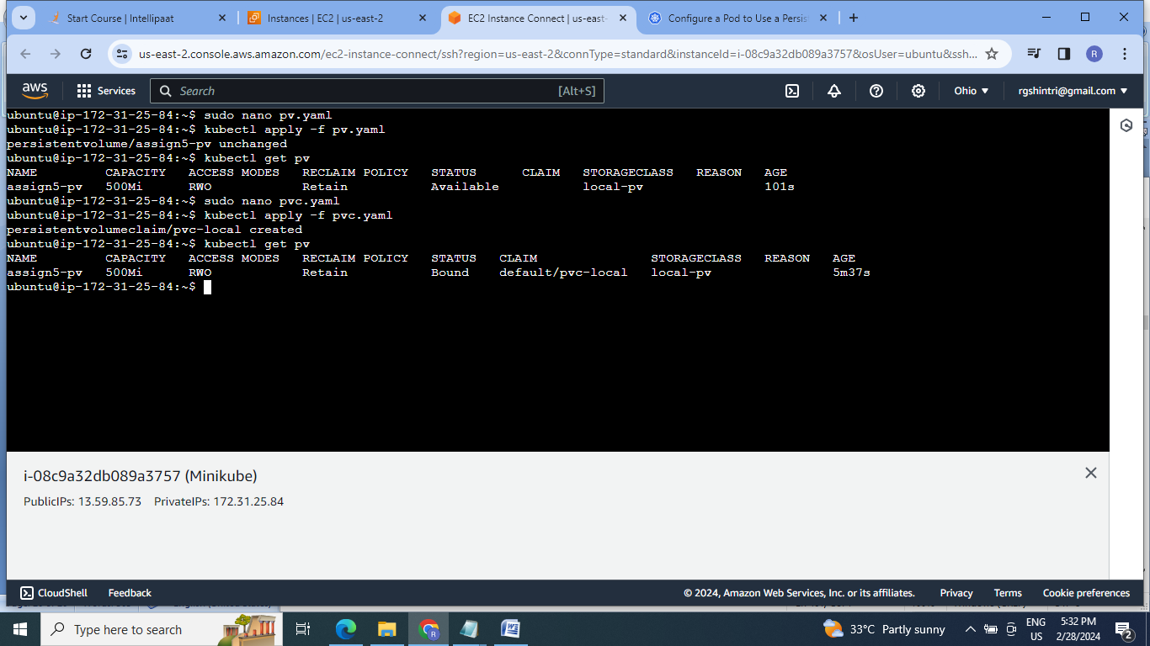

2.Create the pod:

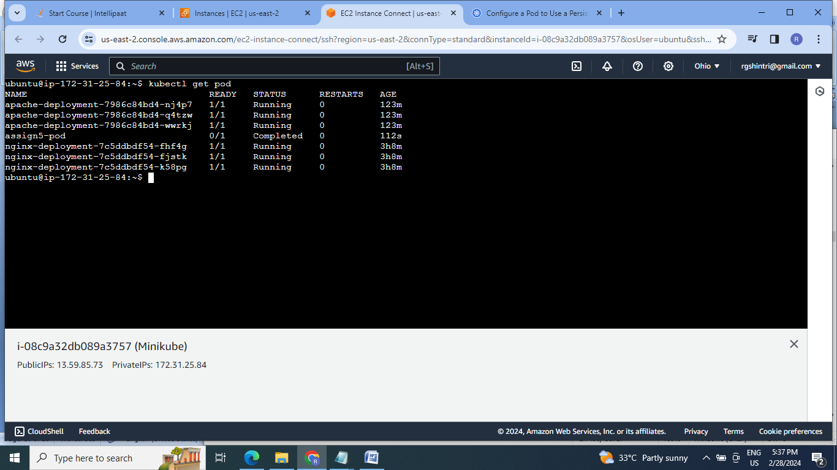

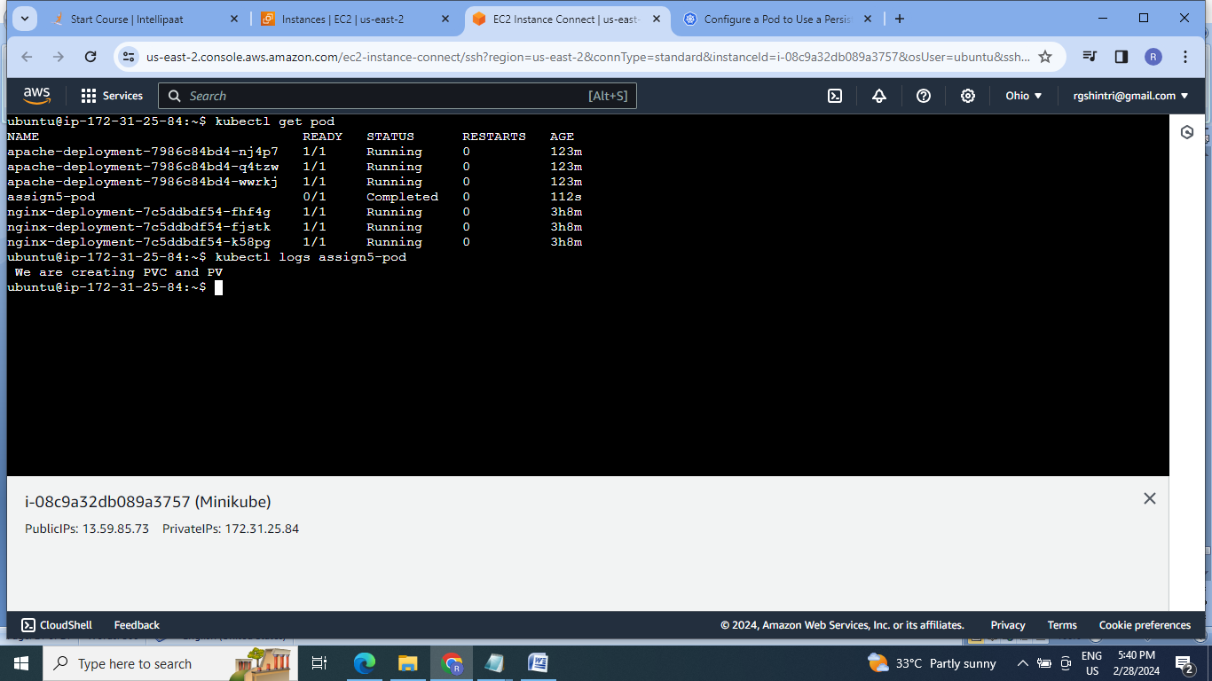

3.create a secret “xyzIsthebest”

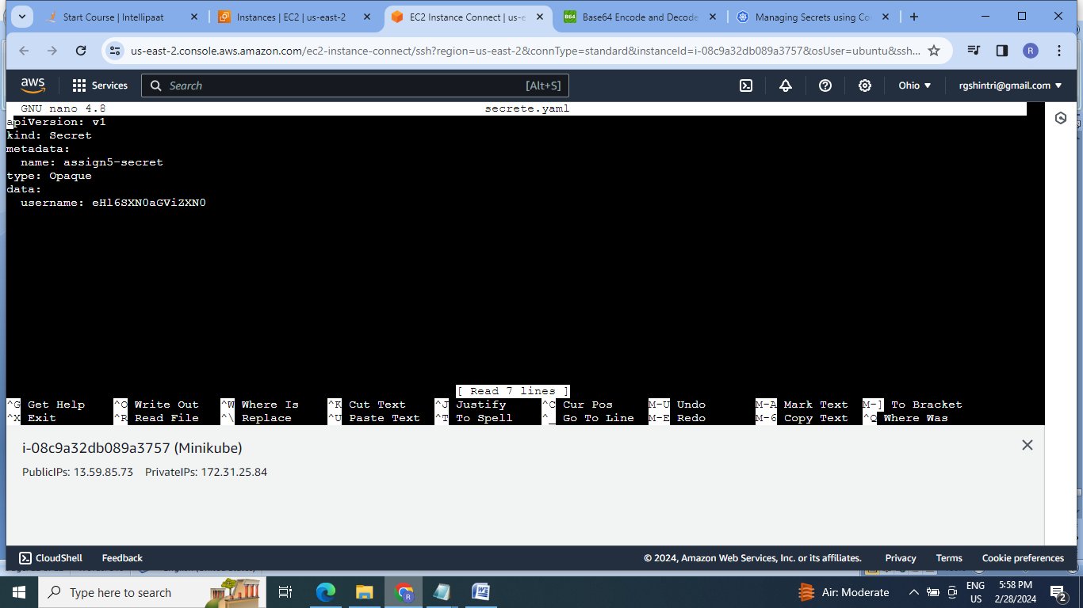

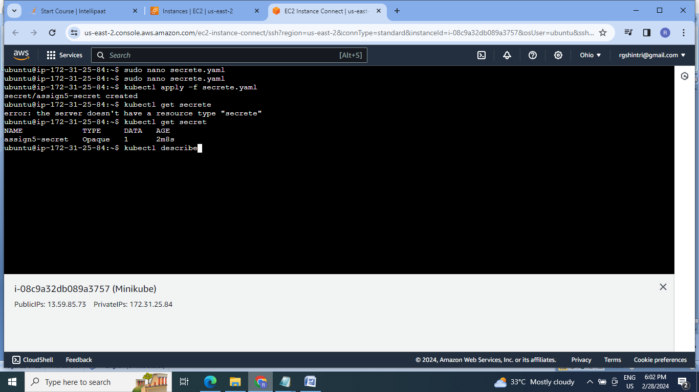

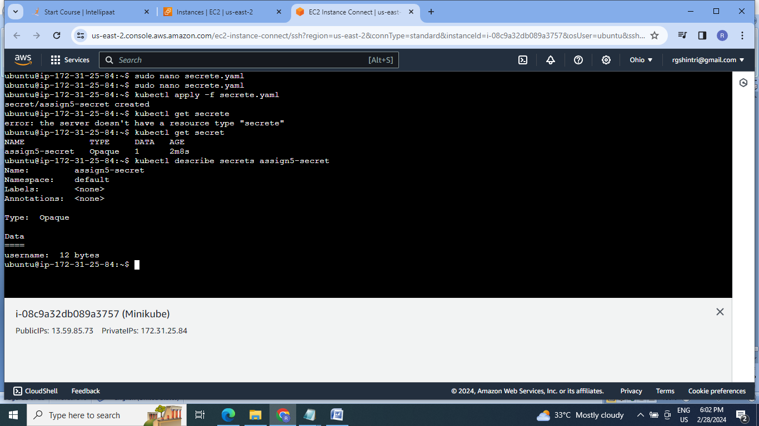

4.Taint one of the nodes of the cluster

Create the cluster:

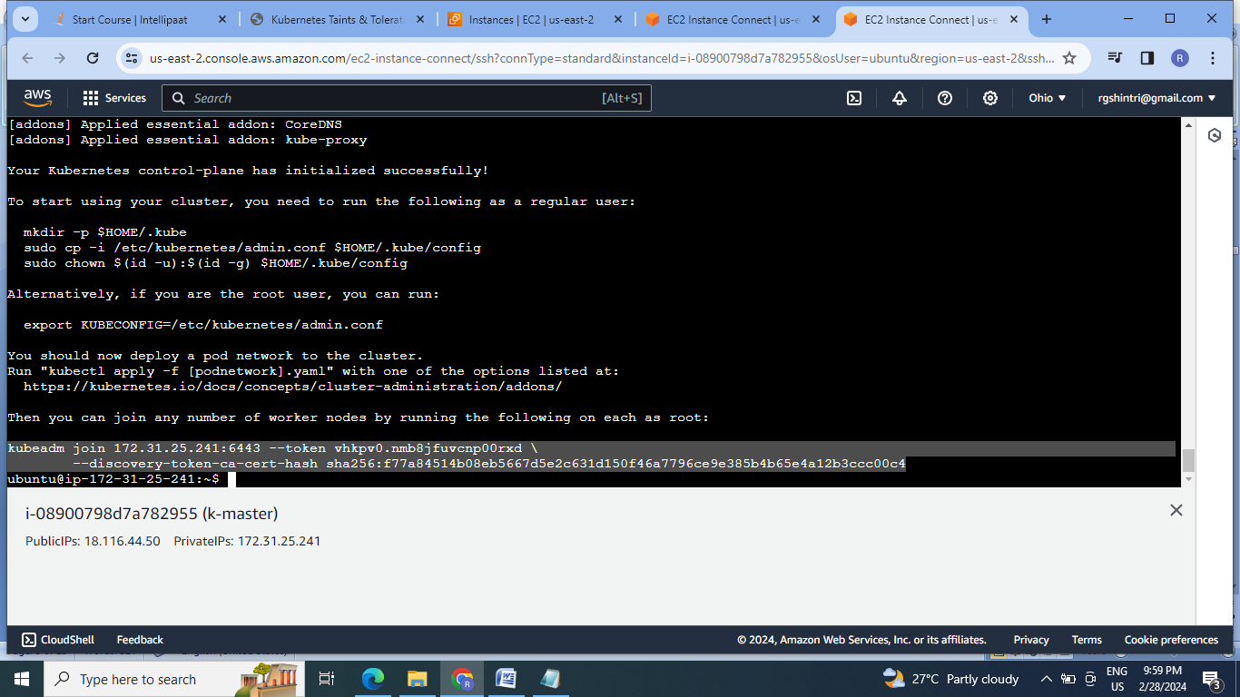

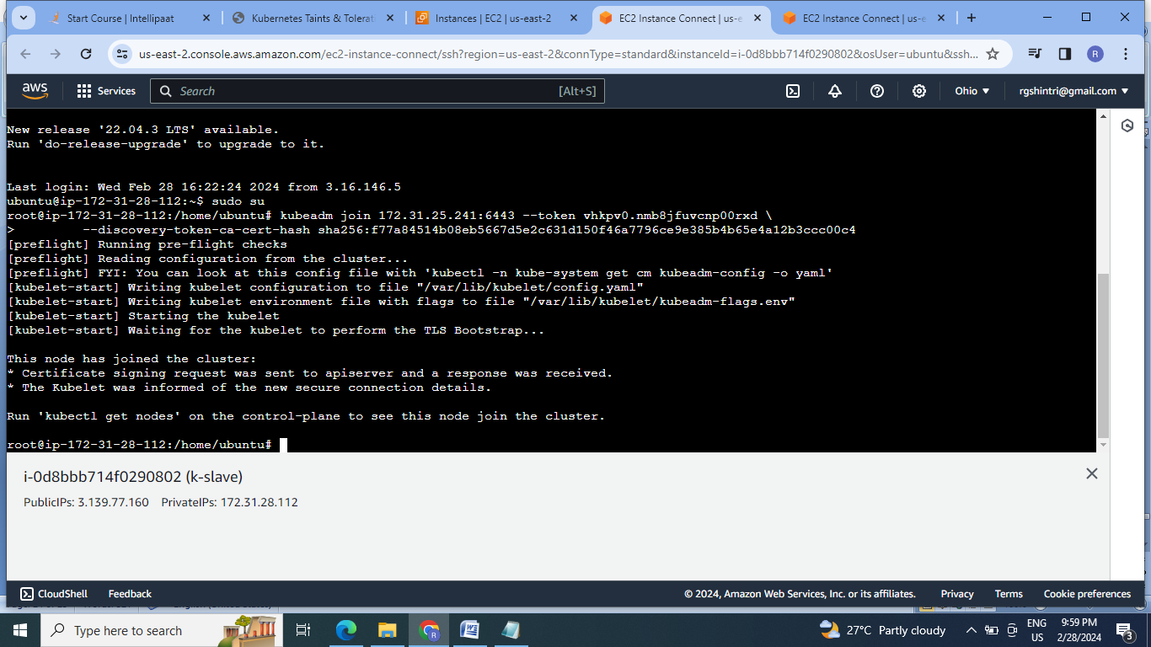

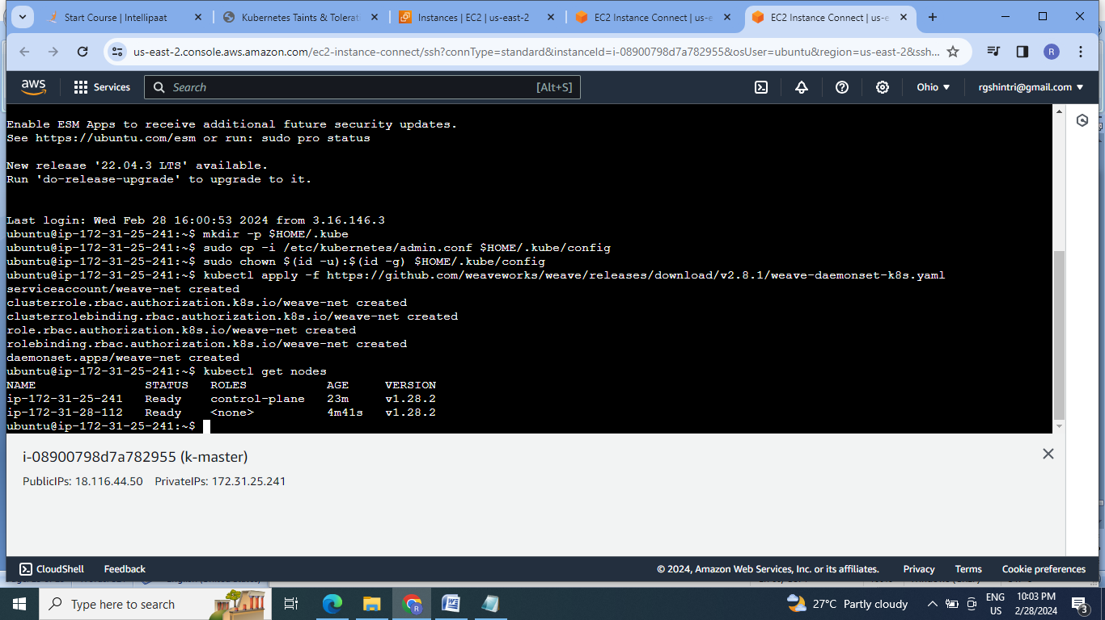

2. Taint the slave:

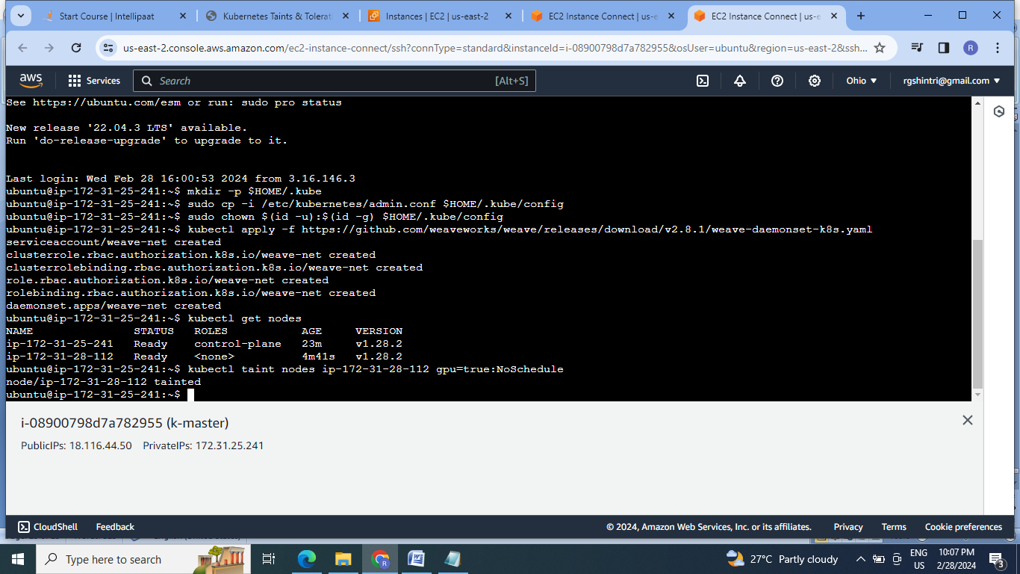

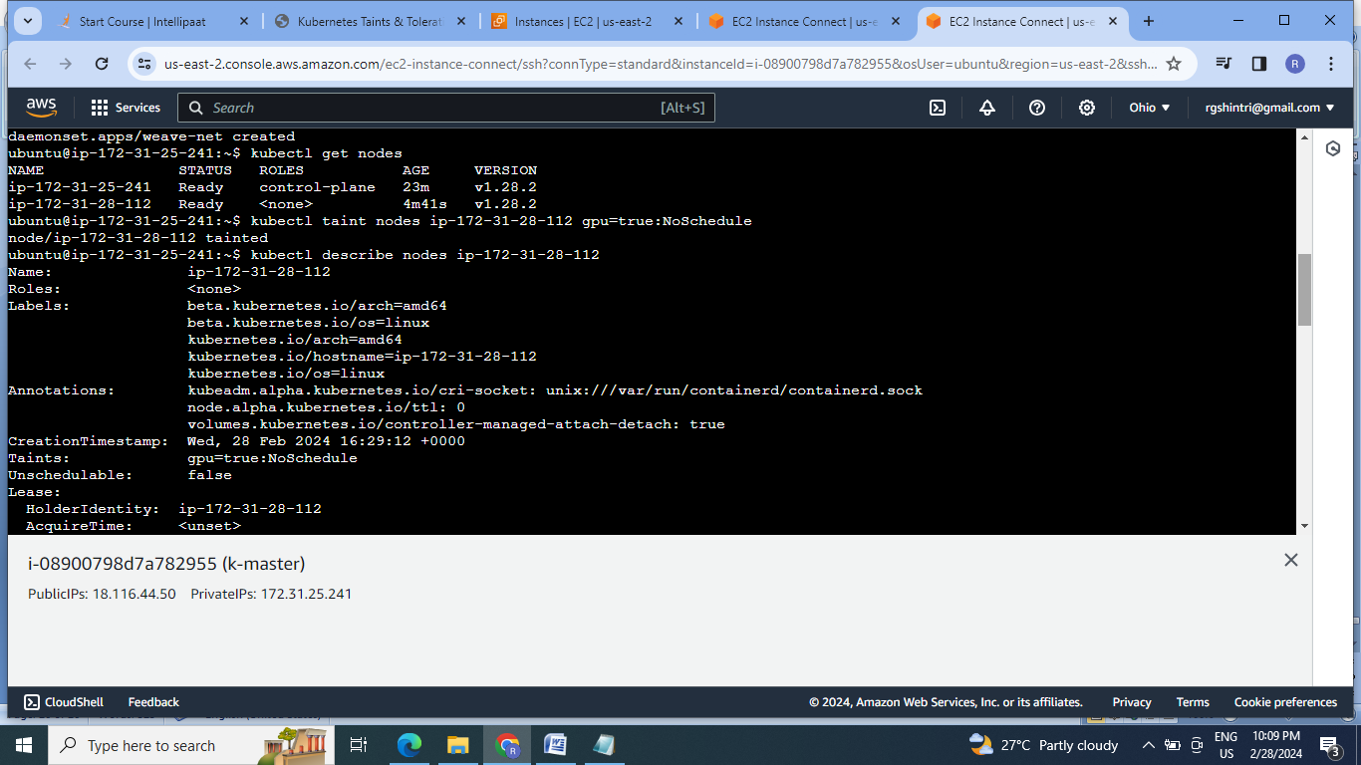

**Conclusion:** Kubernetes is the container orchestration tool that works on pods which is the cluster of containers. It has ability to auto scale & auto heal. This makes the k8s good platform to deploy the application.

